Danny Zac Moncy
ENGL 11000
Assignment 13
Beginners’ CrossFit
Whether you are a newbie to the exercising lifestyle or a fitness freak who is trying out a different style, it’s always good to start with the basics. You want to start slow and steady, and eventually move up in domain. So without further ado, here’s few simple workouts that you can use to begin with:
Push-ups and Burpees (5 Sets)
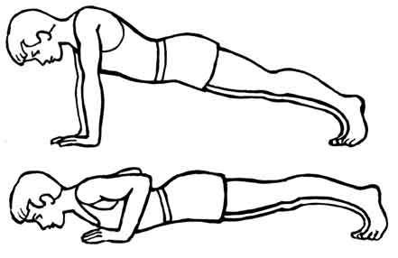
Do 5 push-ups, followed by 5 Burpees. Do 5 Sets of each. Finish off with a mile-run.
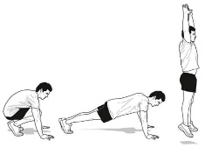

Body Weight Workout (3 Rounds)
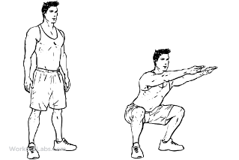
Do 3 Rounds of 10 each.
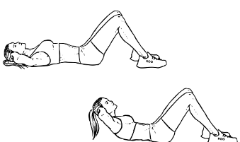
- Sit-ups
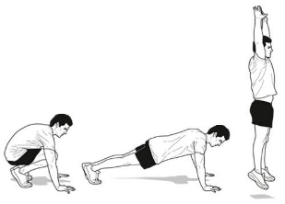
- Push-ups
- Air Squats
- Burpees
Jump Ropes and Medicine Balls
Start with 50 turns of jump ropes. Then, do squats with a medicine ball about arm's length from a wall. Bounce the ball off the wall at around 10 feet above you after the squat, then catch the ball. Then, back to the jump ropes. Do 3 rounds.
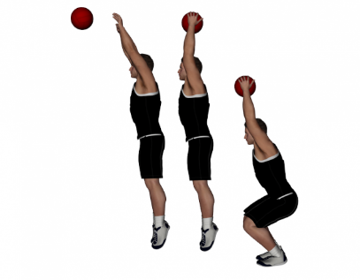
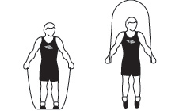

Kettlebell Swings and Thrusters (10 to 1 WOD)
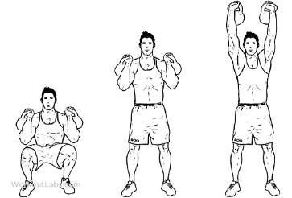
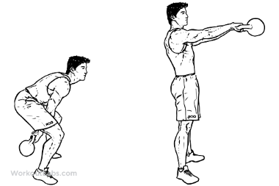
Start with 10 Kettlebell Swings at a moderate weight, followed by 10 Kettlebell Thrusters. 30 Second break. Then, do 9 Kettlebell Swings followed by 9 Kettlebell Thrusters. 30 Second break. Then do 8 of each, and so on until the last one.

Burpees (6 Minutes)
Do as many as you can in 6 minutes.

Run, Workout, Run…
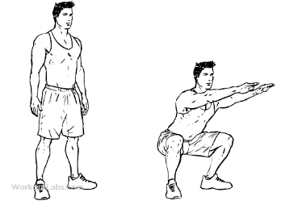
Start with a quarter-mile run. 30 air-squats, 5 pull-ups, 25 sit-ups, 15 burpees. Finish with another-quarter mile run.
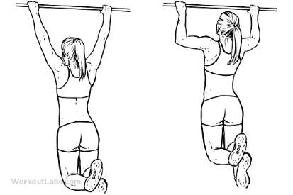
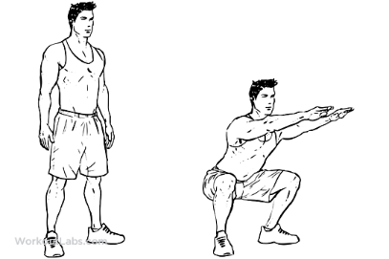
Burpees and Box Jumps
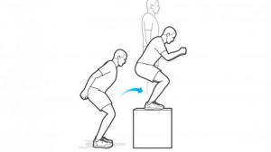
1 Burpee. Jump up on the Box. Hop Back. Another Burpee. Do as many as you can under 5 minutes.

20 to 5 Deadlifts and Burpees
Start with 20 deadlifts and 20 burpees. Then 15 deadlifts and 15 Burpees. Then 10 of each. And finish with 5 of each.
